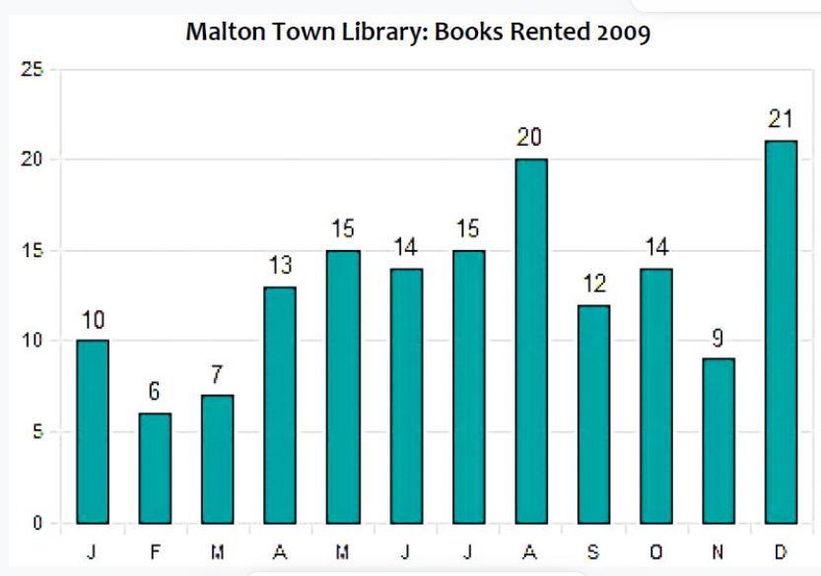
The bar chart illustrates how many books were rented at the library in Molton Town during 2009.

The figure initially stood at 10 before dropping markedly to 6 in February, but it jumped to 15 in March. There was some fluctuation until July, after which it rose significantly to 20 in the following month. There was a sharp fall in September, as it reached 12, but it increased slightly in October, reaching 14. After it fell again to 9 in November, it rose dramatically until December, when it reached a high of 21.

